**Protocol of the Cooling Bath KISS K12**

This bath is part of HighSeasC02 and should be used for pH spectro.

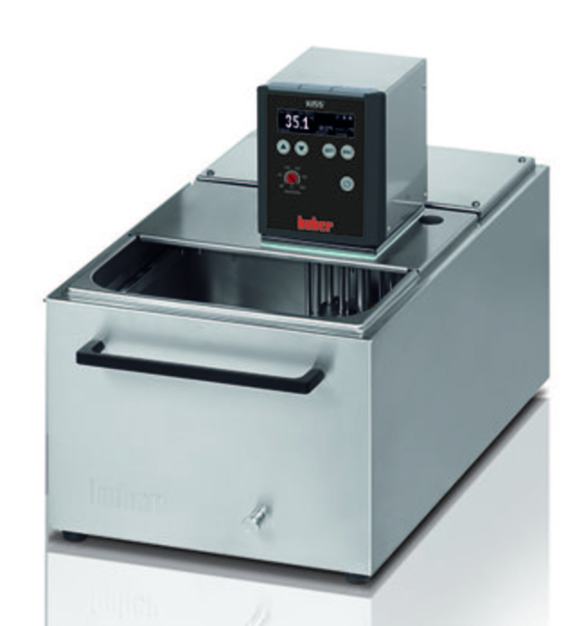

A

B

C

**1 ) Switch the batch ON/OFF.**

To switch ON/OFF the bath, 3 buttons will be used:

- First, one at the rear of the cuve (A).

- Second, one at the rear of the controller unit (B).

- Third, one at the front side of the controller unit (C).

- Switch ON the cuve by positioning the button at the down position in position 1 (**Figure A**).

- Switch ON the polystat by positioning the button in position 1 (**Figure B**).

- Switch ON the regulation by hiting the bottom right button (**Figure C**). Now you will hear the pumps and the

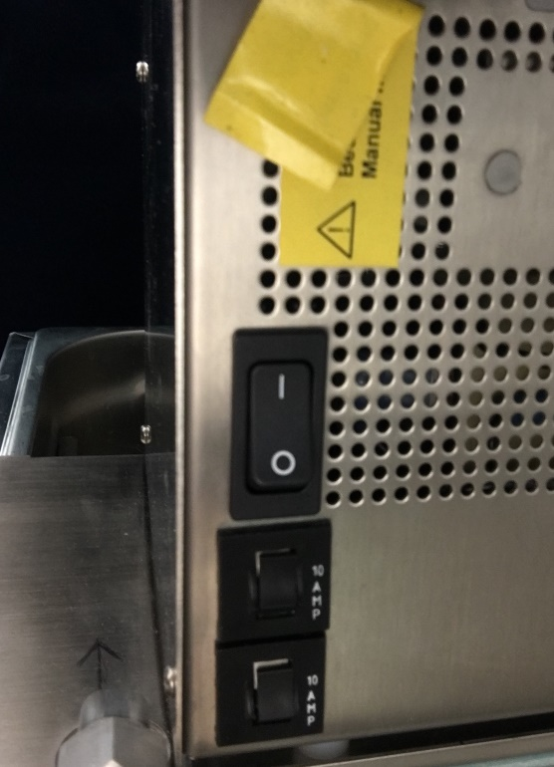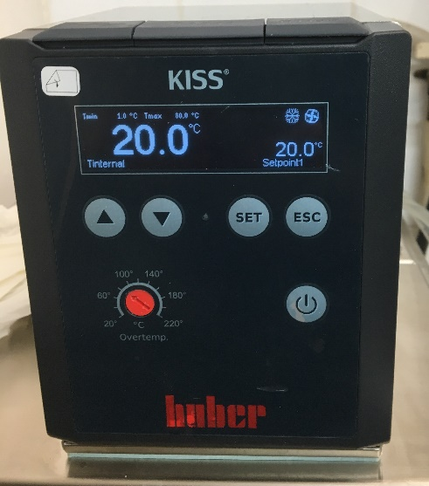

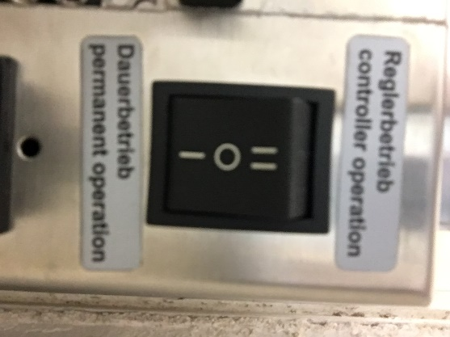

**Figure A Figure B Figure C**

To switch OFF the bath, hit **button** **C** to stop the regulation, then **button B** on “0” to switch off the polystat and then **button A** on “0” to switch of the cuve.

**2) Cleaning and maintenance.**

Please, change the water at least every months or less if you see lot of biofouling at the bottom of the cuve.

Think also to change or clean the 2 tubes to remove biofouling inside the tubes. To clean them, put them in a bucket with 10% HCl (HCl must be inside the tubes) or change them with new ones.

After use, keep the water inside the cuve but dry and clean any drops or water on the inox to prevent rusting.